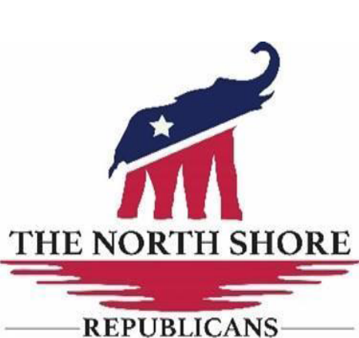

2025 TNSR Calendar of Events
- January 13th – Regular meeting – Vote on new Board members
- February 10th – Regular meeting – Meet and Greet New Board Members
- March 3rd – Regular meeting - Webpage & Social Media training
- April 7th – Guest Speaker: Students applying for Scholarships
- April 26th – Lago Fest (https://www.lagofest.com/)
- May 12th – Regular meeting
- May 19th – Guest Speaker: Terry Hall – TURF (www.TEXASTURF.org)
- June – No meeting
- July 4th- Lago Vista Liberty Celebration Parade – Volunteers needed 8am decorate boat float 10am parade – ride the boat float down Dawn
- July 12th – Independence Celebration Picnic Bar-K Pavillion-11-4pm
- August – No meeting
- September 8th – Guest Speaker: Jonathan Saenz, Esq.-Texas Values (https://txvalues.org/)ocal
- October 1st – Meet Local City Council Candidates @LVHS coordinated with Chamber of Commerce
- October 6th – Regular meeting-voting 2026 board members
- November 10th – Veterans Appreciation – Guest Speaker
- December 13th – End of Year Celebration Dinner – Blue Bonnet
Red highlighted dates are on 1st Monday of that month and includes Specials events that are not on regular 2nd Monday meeting dates.
Pause for the Summer Months except July picnic
Calendar subject to change

